**Comments on the dissertation by Philipp Scholl (Hacker).**

**Chapter 2 Bolometry of Fusion Plasmas**

In general, the title is too broad and the structure needs to be adjusted somewhat. The title could be changed to "Bolometry at W7-X", which would be closer to the work presented. Title for the first part could be "Overview of detectors for bolometry for fusion plasma", the second part "W7-X Bolometer camera construction". A subsection on 'Data acquisition' can be added (see point 3), which can be linked to chapter 3 on feedback control of plasma radiation.

As a general recommendation, text that is not relevant to the content of the section can be omitted. The errors in the text and equations should be corrected. Some selected comments are listed below. Further comments can be found in the text.

**Comments:**

1) Remove the title 2.1.1, as this is the only subsection in 2.1.

2) Delete the not-relevant parts (see the comments next to the text for details).

3) Add a subsection on ‘Data acquisition (DAQ)’ on P29

4) Correction of equation 2.2 (P36).

5) P37: correction of the text. This is actually for W7-AS bolometer system.

6) P38 Delete the non-relevant part. Correct the mistakes.

7) Fig.2.10 Improve the quality of the middle plot.

8) Fig.2.13 Improve the quality of the left plot.

9) To illustrate the Wheatstone bridge: Figs. 2.9 and 2.14 are almost identical. One of them is sufficient.

10) Equation 2.18 has errors. Correct them.

11) Figure 2.15: Use the realistic detector efficiency for the W7-X bolometer. The suggested figure can be found on the page with the "**Note on detector efficiency".**

12) P51: The 'DAQ' part can be placed on P29.

13) P52: Briefly state Ts,max and Ts,min.

14) P59: Equation 2.22 is not mentioned in the text.

15) Correction of the factor of the plasma volume VP for calculation of the radiated power: if r=1.35ra (later 1.3 ra used), the effective plasma volume is ∝ r^2. Hence, VP=1.3^2*VLCFS ≈1.7 VLCFS (instead of 1.3VLCFS). Please provide corrections throughout the thesis.

16) Correction of Eq. 2.23 (see comment on P61)

17) P63: change the title ‘Local’ to ‘Chord Brightness Profile’

18) Fig. 2.23: The effective radius of each channel is calculated using Eq. 2.28 (a) and (b). Obviously, the values from (b) are not reasonable, which can be seen from the normalized reff/ra~0.5 for ch16 in HBC whose LoS passes through the plasma center. Equation 2.28(b) and the corresponding curves in Fig. 2.23 can be eliminated.

19) Fig. 2.24: The title of the abscissa is "normalized radius [r/ra]". Please correct this as well for other relevant diagrams in the thesis.

20) P 69-P74: Very detailed description of other tomography methods, such as Radon transformation and Tikhonov regularization. They should be shortened and inserted as an introduction in chapter 5 on bolometer tomography.

21) Correction of Eq. 2.33 and 2.34.

22) Fig. 2.27 and Fig. 5.41: Power balance can be presented as results. Perhaps in a new (short) chapter: e.g. Chapter 6 Application of bolometer results in the global power balance. Also, Fig. 2.27 and Fig. 5.41 are for the same discharge and almost identical. The part relevant to Fig. 2.27 can be included in the later results, as shown in Fig. 5.41.

23) P78-79: Fig. 2.26 and 2.27 seem to be in the wrong section (they are better suited to RESULTS). See comment 22.

**Chapter 5** **Two-dimensional radiation inversion (132 pages)**

In this chapter, the quality of the bolomeetr tomography for 2D radiation profile reconstruction with the MFR method has been tested using phantom simulations. Selected pairs of smoothing factors for the core and the SOL plasma region, Kani={Kcore,Kedge}, have been used (see the list of *phantom simulation examples* below). The Kani parameters are used to regularize the weighting by smoothing the emission distribution and therefore play a key role in the validation of the tomography algorithm. It is found that due to the multidimensional parameter dependence of the quality of the MFR results, attempting to find optimal configurations or sets of coefficients has proven difficult. Major discrepancies between phantom and tomogram were observed.

However, in the later part, reconstruction of the 2D radiation distribution was performed based on the bolometer measurements with a kani = {2, 0.25}. It would be good to clarify the reasons for choosing this value, e.g. that they can produce the best tomogram, i.e. with the least discrepancy between phantom and tomogram and the 1D radial profiles obtained from the phantom and the tomogram. A systematic scan of Kani in a larger area covering the Kani used for experimental data is necessary.

The Main results in the later part:

1. XP20180725.44 Reconstruction of a small plasma radiation (using kani = {2, 0.25}; however, no justification is given); qualitative results of 2D radiation distributions for the normal phase and the degraded small plasma were obtained.
2. XP20180809.13 Core radiation enhancement due to W-injections by LBO
3. XP20181010.32 The upper X-point radiation is visible; this corresponds to the results of the RGS method (relative gradient smoothing).

In addition, global power balance was performed for two discharges: one is the discharge performed using the real-time feedback control of Prad XP20181010.32 and the other is the small plasma XP20180725.44.

To improve the work, errors must be corrected and the comments and suggestions need to be taken into account. Some of these are listed below. Further comments can be found in the text.

**Major points**

1. **To be corrected:**

* Eq. 5.11 (RGS method)
* Complete Eq. 5.12
* Correct 1.3Vp as 1.7Vp (e.g. P241)
* Distinguish between the geometric factor T for tomographic reconstruction and Etendu (see Eq. 2.26) for a bolometer camera. Correct the text in section 5.2.2 (see comments on P246).
* Eq. 5.16 (see the comments on P262)
* In 1D-radiation radial profile e.g. in Fig. 5.30(d), the x-axis should be labeled as ‘normalized radius’ .
* Density unit should be [1019 m-3].
* P329:Figure 5.38 (a) and (b) are the same.
* **…**

1. P314 5.3.4. Geometry Error Propagation for Reconstructions: This part would make more sense if the reconstruction algorithm is more validated. For the status of the MFR method used, no effects can be seen (see conclusion). It can therefore be omitted.
2. P334: The result of the kani value is expected here, as this will be used in the next section 5.4. Tomography of Experimental Data.

**Suggestions:**

Please shorten the text by deleting some initial exercises that have nothing to do with the main part of the paper. Alternatively, you can include them in the appendix. These parts are:

- P248-P261 (upper part) Calculating the geometry of the artificial bolometer camera. This part is not necessary as it does not contribute to or improve the main results of this chapter.

- P311-P314: Fig. 5.33: The corresponding part can be omitted;

- P268-292: These parts show the detail exercises with different phantoms using selected Kani pairs to perform the tomographic reconstructions to show the unsatisfactory results and therefore *further investigate the* *weighting method and anisotropy coefficient*. One of these examples is actually sufficient.

**Note to phantom simulation examples**:

Fig. 5.12 kani={10.,0.5}

Fig. 5.26 (a) Kani={0.3,0.3} (b) Kani={1.5,0.25}

Fig. 5.28 Kani={0.3,0.3}

Fig. 5.29 Kani={0.3,0.3}

Fig. 5.30 Kani={2.0,0.1}

Fig.5.31 (a) Kani={2.0,0.3} (b) Kani={20.,0.3} (c) Kani={2.,0.6}

Fig. 5.32 Kani={2.0,0.1}

Fig.5.33 Kani={0.3,0.2} in the text on P311 while in figure caption Kani={0.3,0.2}.

Fig. 5.35 Kcore,Kedge={2,2};

Fig. 5.36 Kcore<1; kedge>1;

Fig. 5.37 Kcore,Kedge={2,2};

Fig. 5.40 Kcore<1.1;

**Note to detector efficiency**:

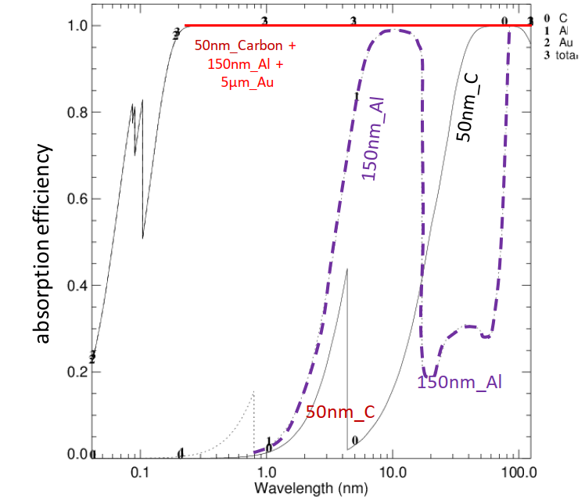 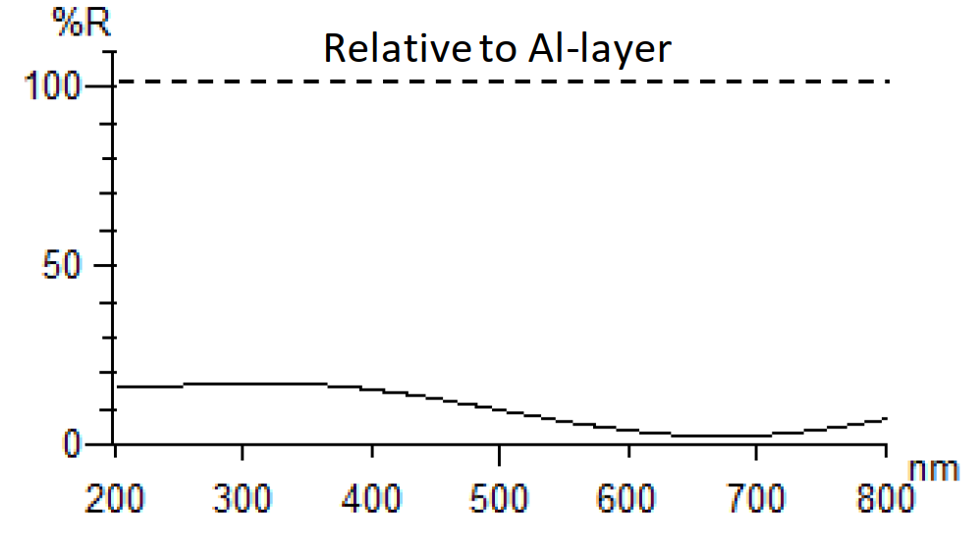

**Figure 2.15** (a) The calculated absorption efficiency of the combined absorber layer (50nm_carbon + 150nm_Al + 5µm_Au) for the spectral range from 100nm to 0.2nm (VUV+soft X-ray) showing a high detector efficiency (~100%) covering the main spectrum emitted by impurity ions in the W7-X plasma. (b) The reflectance of the detector with 50nm carbon coating relative to the Al layer* covering the gold absorber shows a significant reduction in reflectance for photons with wavelengths from 200nm to 800nm [S. Schmitt, IMM Fraunhofer IMM, 2016]. These results show that the blackened bolometer detector at W7-X has sufficient spectral responsivity for visible light, VUV and soft X-rays.

Further information:

1. The detection efﬁciency was calculated from the tabulated coefﬁcients of Henke et al [Henke B.L., Gullikson E.M. and Davis J.C. 1993 At. Data Nucl. Data 54 181]
2. * We received the detector from the manufacturer in 2016 with an Al layer, which is not what we wanted. The Al layer (which has a higher reflectance than gold, e.g. for photons with wavelengths of 200nm-500nm) should only serve as a heat conductor bridging the gold absorber and the heat sink (Si frame). To correct this fault, 50 nm of carbon was later coated onto the Al layer (based on our calculations and discussions with the manufacturer).